Arduino

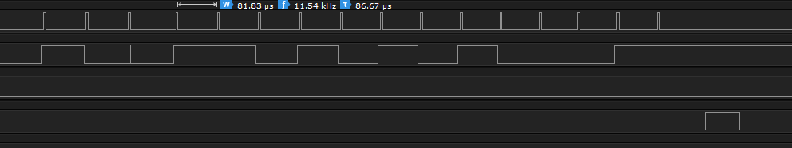

70us

Myrio SPI inbuilt had some problem

3 V

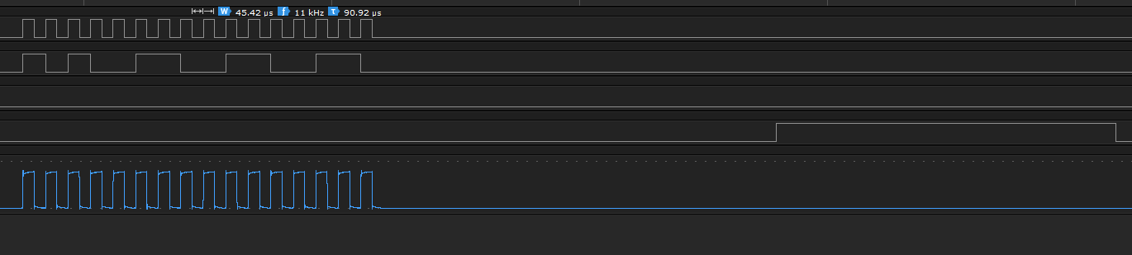

1.37 ms

2V

